The following are the sections of the website that needs accurate data from the college.
- Home page - counter
We need data on all the 4 metrics, if those data aren’t available or want to change the data label, please let us know, we will replace it with relevant information.
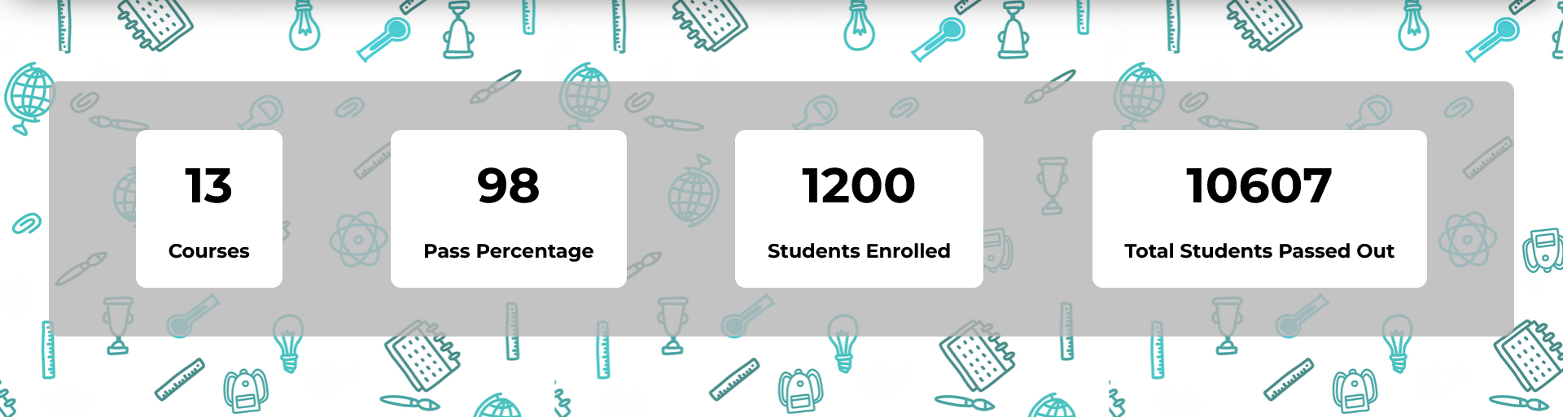

- Home page – Pride of the College
Please give us the list of the students to be included. We can get that from the current website, but as it has been redirecting to the /new section of the website, we cannot intercept that page.
The list would include -> (Image, Name, Course, Rank)
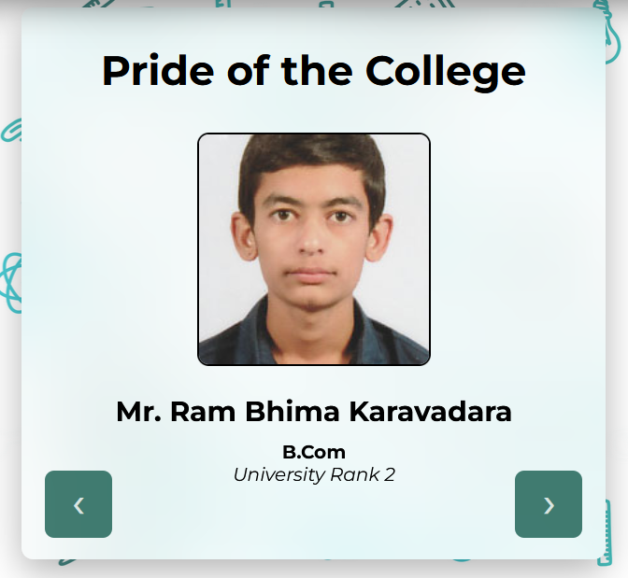

- Home Page – Upcoming Events and Resent Results
Please give us the list of Events and Results to be included.
The list would include -> (Title, Date, Body Text) {same for both events and results}
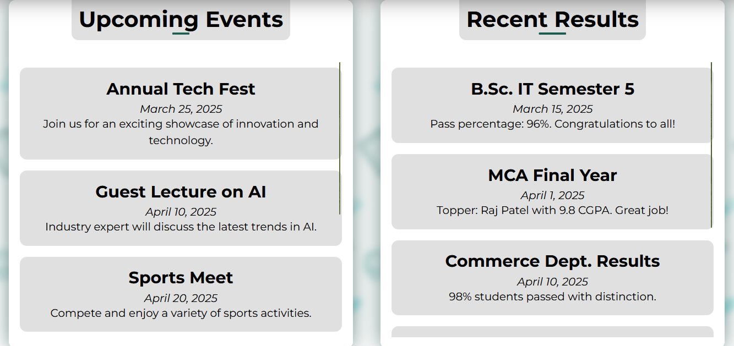
- Home Page - Student Testimonials
Currently we have Dummy Data in this section, so we need real reviews if any. We can also collect positive reviews from google and then rename the section from ‘Student Testimonials’ to ‘Reviews’ or anything else. The downside of collecting reviews from google is that most of them aren’t grammatically correct, therefore, the section quality will be degraded. Editing a review for grammatical accuracy isn’t advisable.


- Home Page – Photos
We would require some more photos that you would like to include in the home page photos section
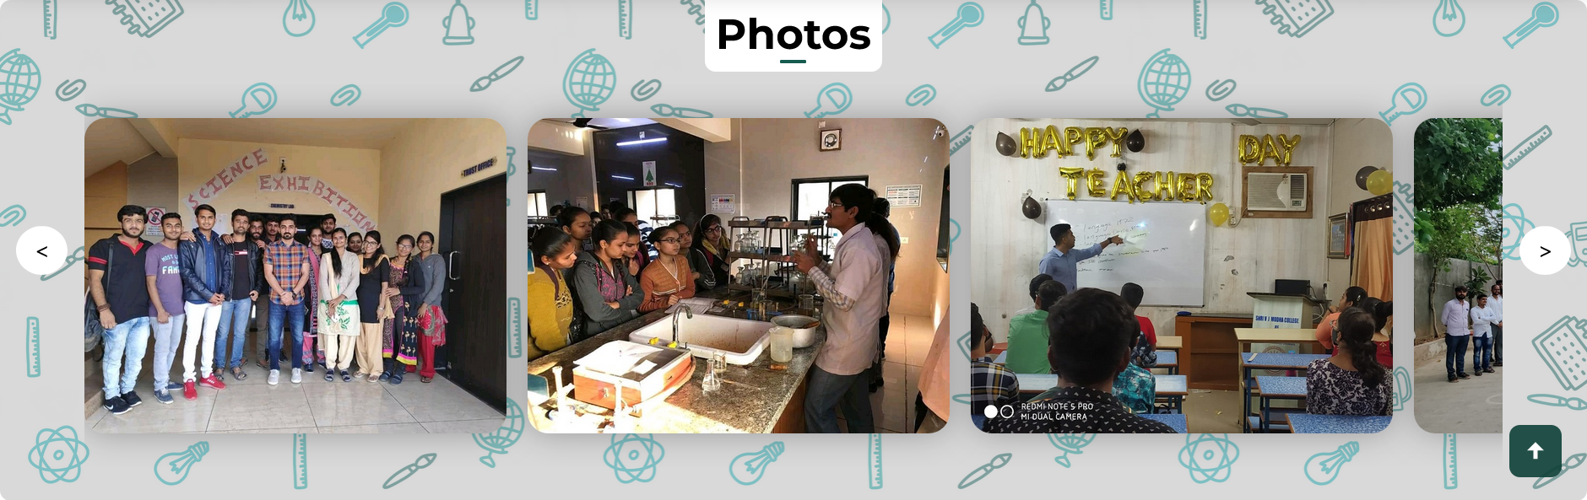

- Labs Section – Computer, Chemistry and Biology Labs
All three labs have few photos and an introduction. We would like to get that introduction text as right now there is only demo text. The biology lab needs few images as we were unable to find images from the website.
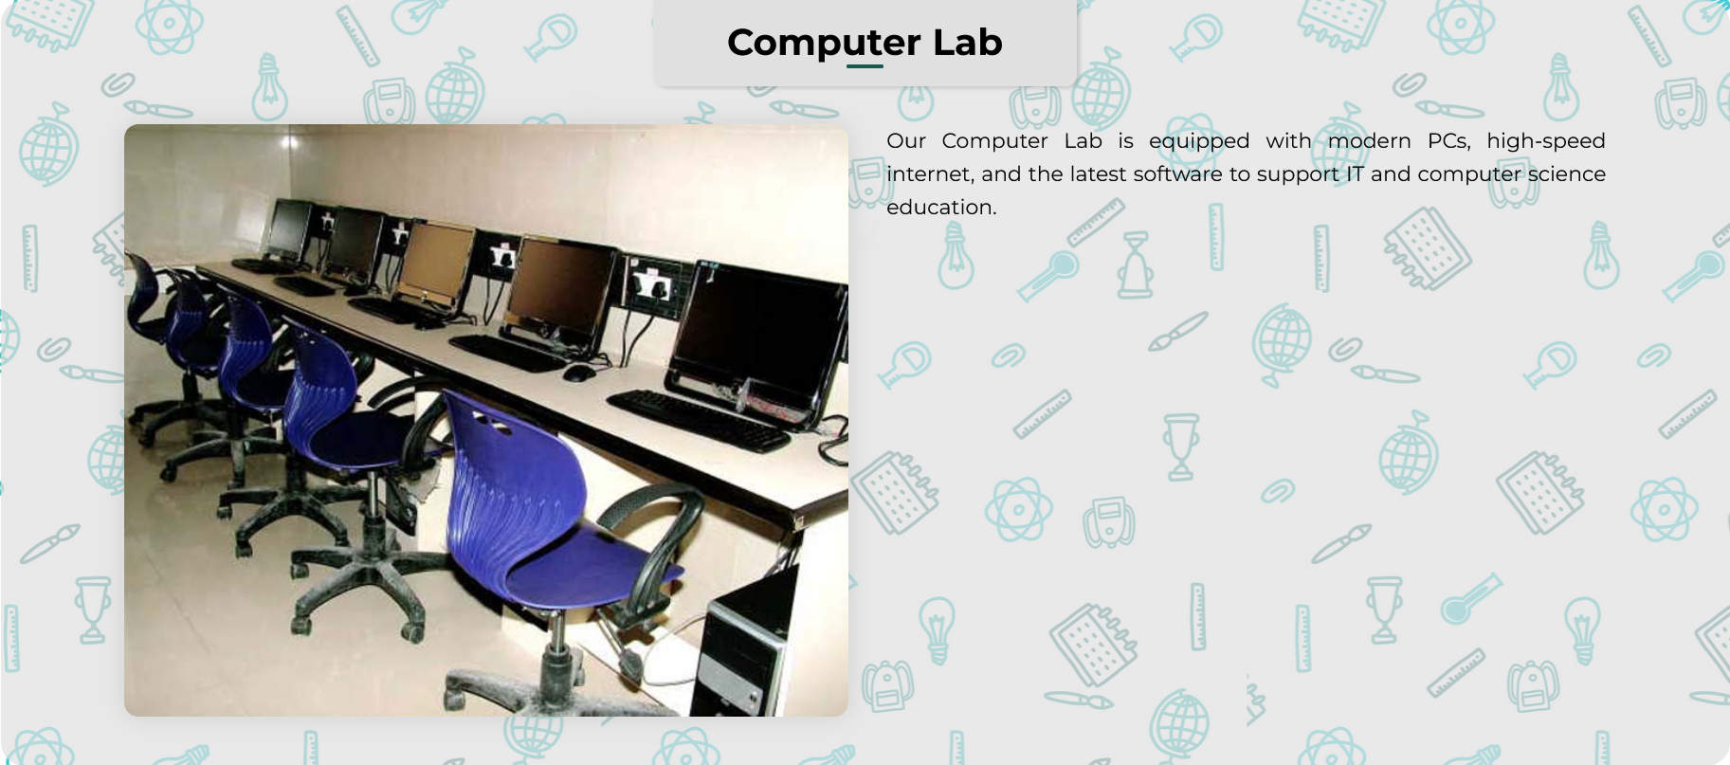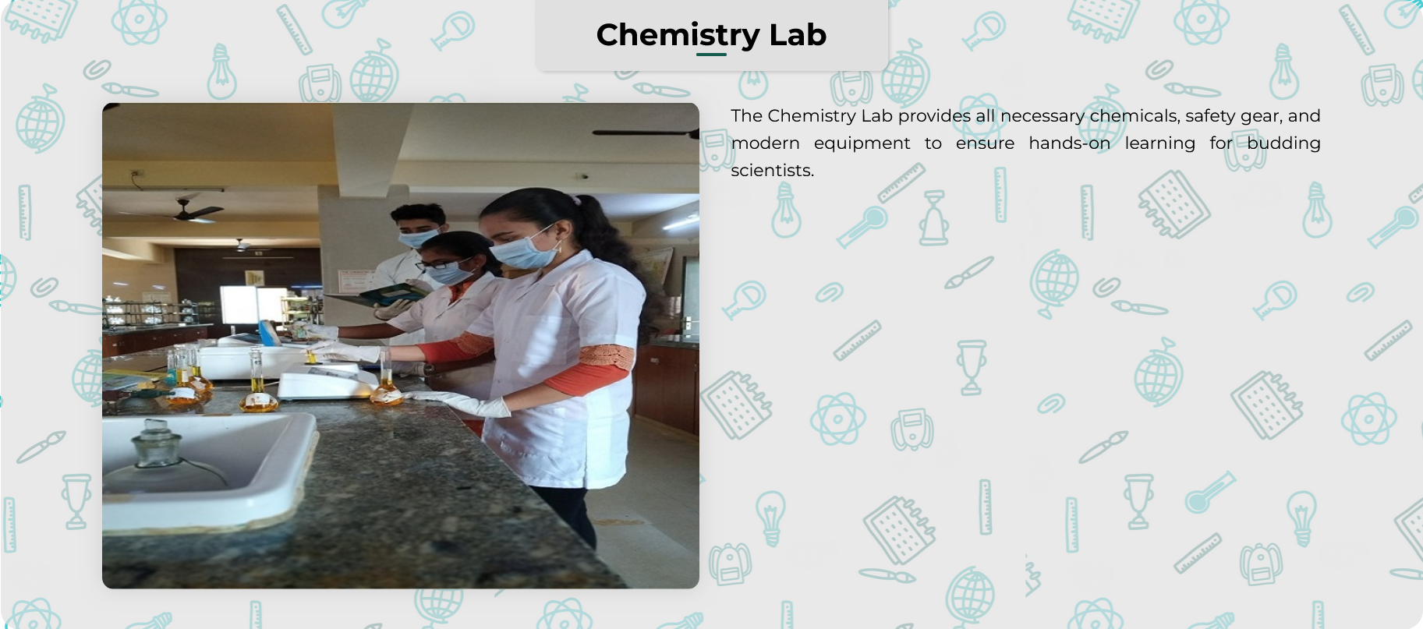

- Home Page – Banner Video
We were told that there is another intro video in the making which would have been ready by April End. To figure out an optimal strategy for ‘bufferless’ video playback on many end users, we need the final video.

- Optionals
Latest Images for anything can be given.
Any other suggestions

